**Survey Monkey Response Notes and Feedback**

Question 1 - Do you like the title & strapline? :

Respondents liked the site name (20:2 / 90%) – no need for change. Confirmed our belief headline was captivating.

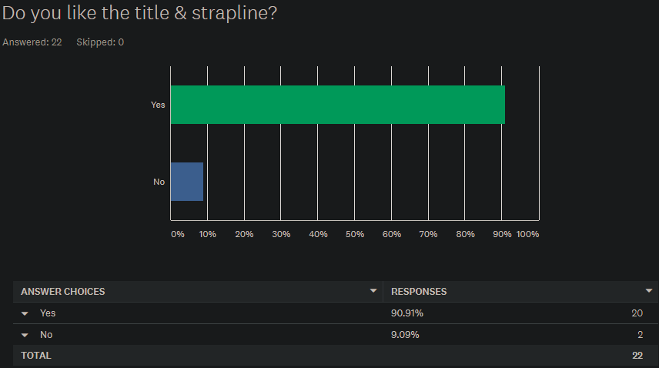

Question 2 - Do you like the layout of the different pages? :

Feedback for the layout of the various pages, mostly positive (17:5 / 77%). Going to disucss changing colour scheme. Feedback:

* “Consistent navigation between slides”
* “Maybe could be more attractive”
* “Layout and colours seem quite basic/retro”

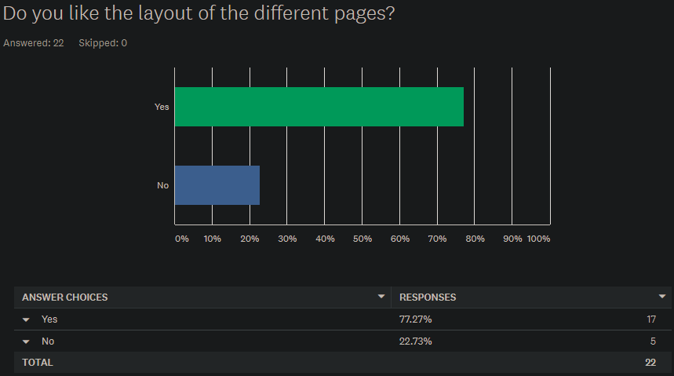

Question 3 – Do you like the colour scheme? :

Colour scheme 50:50 response. Given feedback from the previous question, we are going to brainstorm/test different colour schemes.

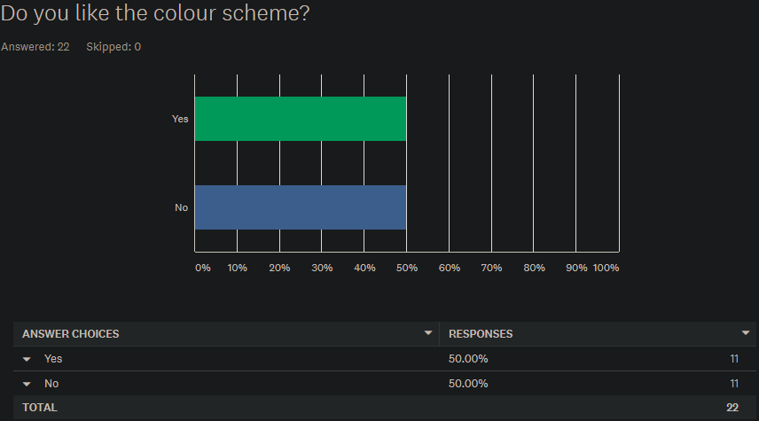

Question 4 - Would you take this quiz? :

Respondents were positive and seemed interested to take the quiz. Feedback:

* People interested to “see how I fare”
* Some said they don’t have time to do “meaningless” quizzes. Maybe we can improve engagement somehow.

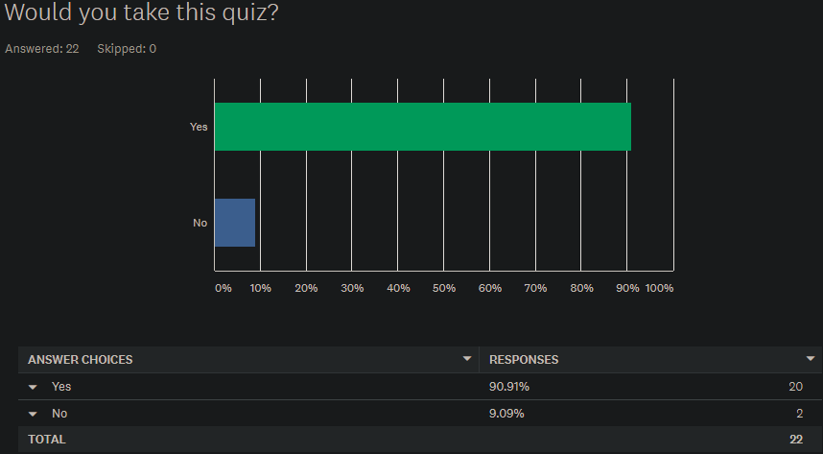

Question 5 – Does the quiz look fun? :

Similar response to the previous question (19: 3 /86%), which is to be expected as people tend to take quizzes that they find fun. Feedback:

* Some said: “looks like statistical data”
* However, some responded positively citing it could be “enlightening”

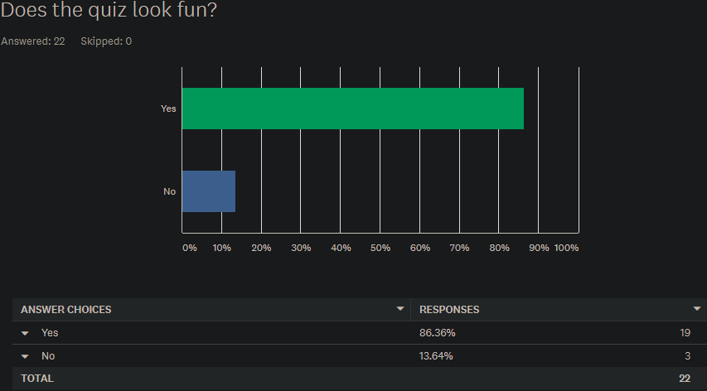

Question 6 – How likely are you to suggest this to a friend?:

Slight majority would recommend to a friend – reassuring us that this could be used as an educational tool as word of mouth is important to success. Could improve this by including social element?

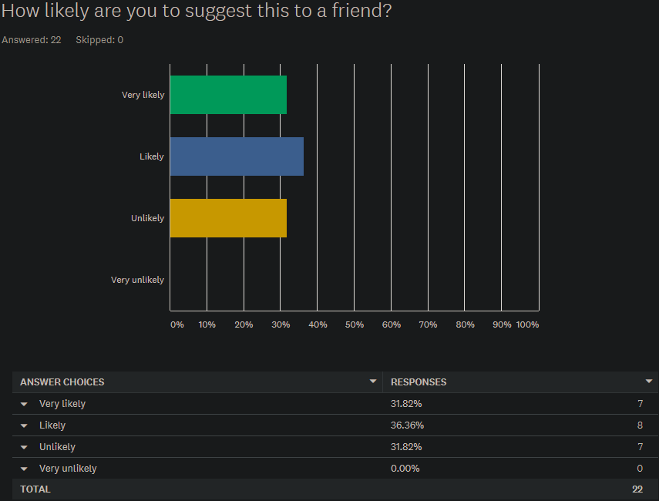

Question 7 – Would you like information on what fakes news is, why it’s dangerous and how to spot it presented on the landing page?:

Strong majority want information on fake news and want to further their understanding. Feedback:

* One respondent suggested a new page for this information, directed to by clicking through on the landing page. Feedback taken on board and will be implemented.

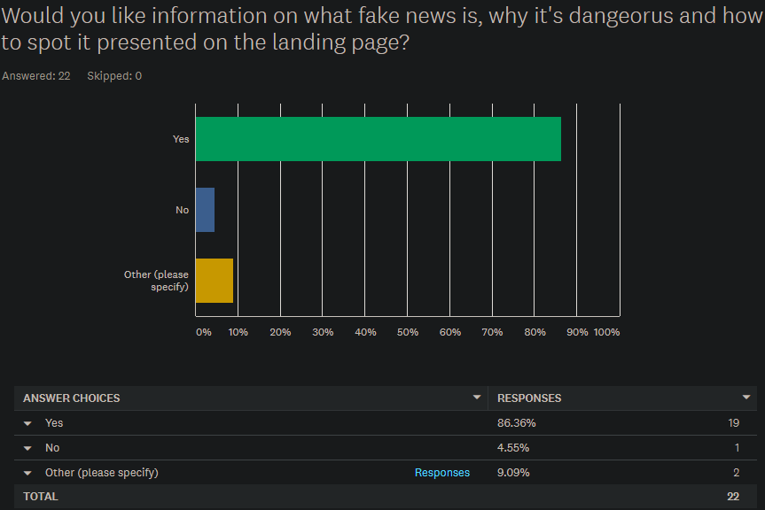

Question 8 – Would you rather have the answers (slide 4) displayed after each question or at the end?:

Respondents mostly agreed (18:4 / 82%) with our initial thought that answers should be shown after each question.

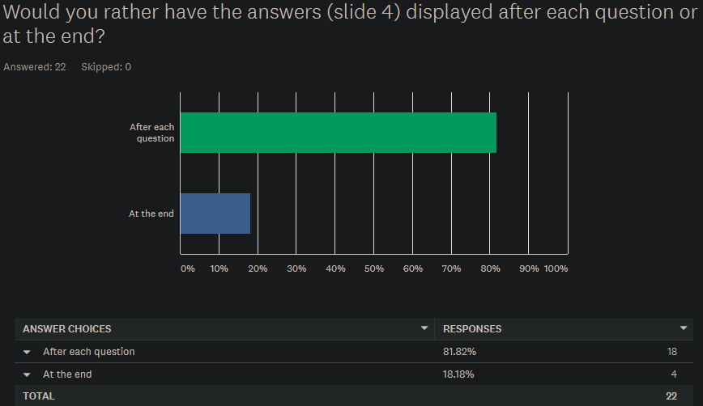

Question 9 – Would you return to this website? If so, what is more likely to make you return?:

80% said they would return to the website, for different reasons; to beat high score, fun and interesting. Feedback:

* Noted that some said that they would only return if we “updated the quiz regularly”.

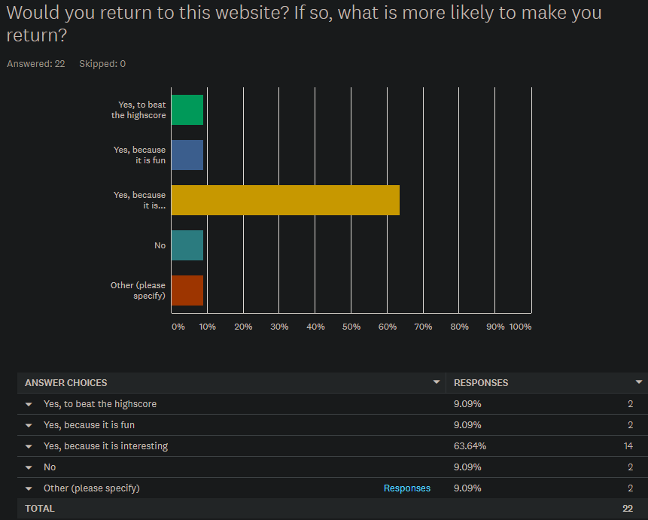

Question 10 – Does this look easy to navigate?:

91% said they thought it was easy to navigate, which means that they think the UI/UX is good.

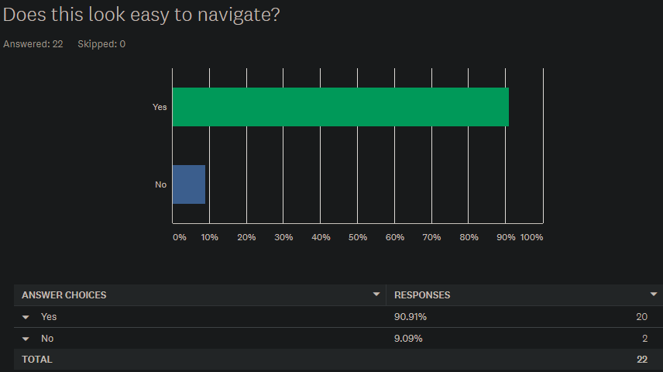

*Self-directed feedback on user questionnaires*

-> could reduce ambiguities in the paper prototype itself / related survey questionnaires. Some users were confused about the site, although a small amount, this could tarnish decisions made on user feedback in future.

Summary

* Name is OK
* Navigation seems OK
* Substantial negative feedback about the colour scheme
* Appealed as interesting to users
* Not a lot of users would suggest to a friend – **add a social element, link to friend / social media account?**